Homework for Atoms
1.) Who was Democritus and what did he believe that matter was made of? Was Democritus correct in his theory, why or why not?

Directions: Fill in the chart based on what you have learned and read.
How are these things similar or different?
The Atoms Family & Matterville | In the REAL Atom, they’re actually called…
1. Perky Patty Proton | 1.
2. Nerdy Nelda Neutron | 2.
3. Enraged Elliot Electron | 3.
4. Nucleus Arcade | 4.
5. Who are the 2 characters in the Nucleus Arcade?  _________________ & _______________ | 5. In the nucleus, the 2 particles are…  ________________ & _______________
6. Enraged Elliot Electron races around  _____________________ | 6. Electrons are found  ____________________
7. The 3 roads in Matterville are  _________________________________,  _________________________________,  _________________________________ | 7. In the REAL atom, the “roads” are actually called ________________

8. Label the parts of this atom:

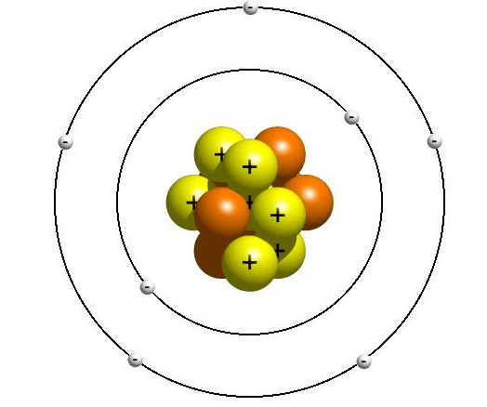

9.) What is an atom?

Atoms are…. ______________________________________________________________________________

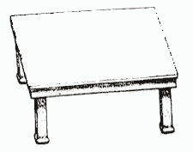
10.) Look at this table. Draw what the atoms would look like in this table:

11.) In class, we learned about the parts of the atom. What were the 3 parts of the atom called?

_________________, ___________________ and _______________________

12.) We also learned about what the parts of the atom look like. Fill in the table below:

Parts of the Atom | What are the charges of this part of the atom? | What is the size of the particle? (large? Small?) | Where is this part of the atom located?
proton
neutron
electrons

13.) Look at the following pictures of an atom. Label where the electrons, neutrons, protons, the nucleus and the energy levels are.
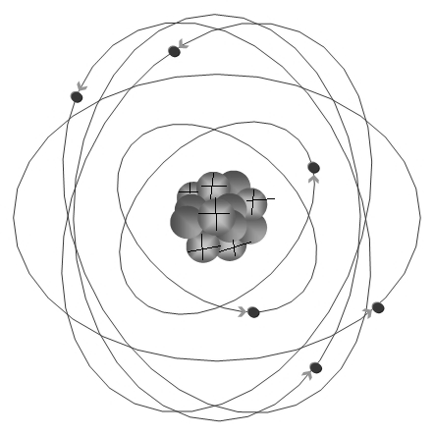

14.) Now take a look at these pictures. Tell me how many electron, protons and neutrons

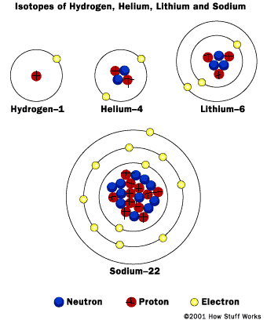
1.) Hydrogen:
protons:
neutrons:
electrons:
2.) Helium:
protons:
neutrons:
electrons:
3.) Lithium
protons:
neutrons:
electrons:

4.) Sodium
protons:
neutrons:
electrons:



